Project
On

Movie Rental

Declaration

I Student Name, student of MCA program, VI Semester of 2008 – 2010 batch at IGNOU University do hereby declare that this report entitled “Movie Rental“ has been carried out by me during this Semester and the same work has not been copied from any source directly without acknowledging for the part/ section that has been adopted from published / non-published works.

Student Name

____________

Table of Contents

- Introduction of company’s profile
- About Project
- Project Objective
- Project Profile
- Proposed System and Targeted User
- Specific Requirement Specifications
- System Development Life Cycle
- Data Design
Entity-Relationship Diagram
- System Design
Data Flow Diagram
UML Diagram
- Bibliography

Introduction

About Project

Abstract

In this case, we will be designing a simple online movie rental. The site will provide a soothing experience for customers. The system will allow more than one category of movies of different banners. Customer can send pick-up request to us for the movie that he wants to borrow for few numbers of days. Our one of the staff member delivered that movie within a day at the customer place and picked up the movie. Rental charges of each movie are same for all our customer but number of movies a user can borrow at a time is depends on its membership plan.

Project Objective

Scope
The project is confined to the intranet in an organization. This application makes sure that security services such as secrecy, authentication, integrity and non-repudiation are provided to the communicating parties.

Objective
This project has been developed keeping in view the security features that need to be implemented in the networks following the fulfillment of these objectives:
- Provide a user friendly interface to the user such that he can borrow movie for few days & he can also create his queue.
- User can make a request of the required movie from his queue for delivery.

Assumptions
The currency followed is Rs as the site provides for only Indian customer base.
- There are different segments, categories, brands where a brand can fall under more than one category.
- The shipment of the goods is not covered under the scope of the case
- Complains by the customers are not handled by the case study.
- Customers have to be validated before the payment can be confirmed.

Project Overview
A customer visits the online movie rental. A customer may select any movie that he wants to borrow or just visit the page and logout. The customer can select a genre, then a language, to get the different movies as he desired. And there are various other ways that a user can search for his desired movie.
The customer can select the movie for putting them in his queue. The process can be repeated for more movies. Once the customer finishes selecting the movie/s the queue can be viewed, if the customer wants to edit the final queue it can be done here. Customer can update or delete movies for his queue anytime.
For final delivery of selected borrowed movie, the customer has to login the portal, if the customer is visiting for the 1st time he must register with the site, else the customer must use the login page to proceed.
Finally customer has to request for the desired movie from the queue for delivery. That movie is delivered at their place within a day also picked up from there after few days or requested by the customer to pick this movie or pick and deliver next movie.

Modules:

- Registration
- Search
- Report
- Security
- Admin
- Staff
- User

Brief Description of the modules:

Registration:
Through this module a person can register with the website. A registered user can add movies to the queue and see rental history and update his profile. A user can keep any number of movies as he wishes, but only the first movie is delivered to him in the next delivery cycle. A person needs to choose a plan to be registered and join with us. Valid email id is required as user id.

Search: This module is the most important module of this project. Visitor & User can search movie by various ways. These ways are explained as below
- By Combination of Language & Genre
- By Alphabet
- By Collection
  - By year like movies of 80's, 90's or 2000
  - By Award Winning movies
(NOTE: These above two options are available for both Indian and International Category)
- By Name of
  - Actor
  - Actress
  - Producer
  - Director

Report:
This module works for us whenever admin or user wants to take a report of any type like…
- Admin can take a report of all payment made by any user during registration
- Admin can also take report of all customer details
- Rental history that shows disc to be delivered as well as or disc to be picked up.

Security: Security is one of the most important aspects of any project. Following security measures have been taken:

Login:

This is a sub module of Security Module. This module authenticates and authorizes the user. If the user has forgotten the password then Once visitor is registered with us, now can borrow movie from us but before that he has to choose or make a queue that he/she want to watch in future. And also reserve his/her movie for delivery at his/her place. Session is created after successful login

Logout:
This module is again sub module of Security. Session expires after successful logout

Captcha
A captcha is a set of letters and or numbers presented under the form of a small picture. The trick is that the captcha containing letters and or numbers is distorted badly. Basically, the captcha is designed to be able to make a distinction between human started submission of web-forms and automated software queries, and help separate them accordingly.

Auto Logout

If no requests come from the same user for the next 30 minutes then user is logged out automatically.
Admin: Admin is the only authorized person who governs this site. He can perform following activities:
- Add Movie/ Membership Plan / Staff
- Update Profile/Password/Movie Details/Movie Image/Number Of Discs
- Delete Movie
- Reports
  - Payment Details
  - Delivery Details
  - Discs Details
  - Posted Feedbacks

User: User can search any movie from his/her choice and make a queue according with that. Now, he/she can reserve any movie or delete any movie from the queue. If he/she reserve any movie its mean that he/she want that movie to be delivered to him.
- My Profile
- Add Movie To Queue/ Deliver or Reserve List
- Update Profile / Password
- View
  - My Queue
  - Rental History
  - Popular Movies
  - Locate Stores
  - New Membership Plans
- Post Feedback

Staff: our Staff person is that, who delivered and take back movie to the respective user on time.
- My Profile
- Update Profile / Password
- Check New Movie Delivery Requests
- Reports New Delivery Requests

Project Profile

► | Product Name | : | Movie Rental
► | Project Objective | : | A customer may select an movie that he wants to borrow and we deliver that movie at his place.
► | SDLC Model | : | Water Fall Model
► | Development Technologies | : | Java/J2EE
► | Application Server | : | Oracle Web logic Application Server Enterprise Edition
► | Back-End Database | : | Oracle Database 10g Enterprise Edition
► | Location | : | Faridabad

Proposed System & Targeted User

Existing system
These days almost all organizations around the globe use a movie renting system to borrow movie from somewhere but we provide movie to the user by providing door-to-door service but only he needs to register with us and add to movie in his queue through their exclusive intranet. But the security provided is not of high standards. More and more unauthorized people are gaining access to confidential data.

Disadvantages:
- The validity of sender is not known.
- The sender may deny borrowing a movie that he has actually wanted and similarly the receiver may deny the receipt that he has actually received.
- Unauthorized people can gain access to classified data.

Proposed system
The system will provide the following security services:

Confidentiality:
Confidentiality is the protection of borrowing movie data from passive attacks. With respect to the release of movie contents, several levels of protection can be identified. The broadest service protects all user data transmitted between two users over a period of time. For example, if a virtual circuit is set up between two systems, this broad Protection would prevent the release of any user data transmitted over the virtual circuit. Narrower forms of this service can also be defined, including the protection of a single message or even specific fields within a message. These refinements are less useful than the broad approach and may even be more complex and expensive to implement. The other aspect of confidentiality is the protection of traffic flow from analysis. This requires that an attacker not be able to observe the source and destination, frequency, length, or other characteristics of the traffic on a communications facility.

Authentication:
The authentication service is concerned with assuring that a communication is authentic. In this case, we provide authentication to the user that his/her detail either its login or its payment details are not shared by any other organization or person.

Integrity:
Integrity basically means ensuring that the data of the customer are not modified once he/she paid his/her payment of the membership plan.

System Requirement Specification

SRS is a document that completely describes what the proposed software should do without describing how the software will do it. The basic goal of requirements phase is to produce the SRS, which describes the complete external behavior of the proposed software. The process of developing an SRS usually helps, forces the client and the user to think, visualize and discuss with others to identify the requirements. Hence the most important advantages are:

- An SRS establishes the basis for agreement between the client and supplies on what the software product will do.
- An SRS provide a reference for validation of the final product.
- A high quality SRS is a prerequisite to high quality software.
- A high quality SRS reduces the development cost.

Tools & Platform Used

Front-End:

Front End
- JSP
- Html
Supported Architectures
- x64
- x86

Supported Operating System
- Microsoft Windows XP
- Microsoft Windows Server 2003
- Windows Vista

Hardware Requirement:

Hardware | Minimum | Recommended
Processer | 1.6 GHz | 2.2 GHz
RAM | 384 MB | 1024 MB
Display | 1024x768 | 1280x1024
Hard Disk RPM | 5400 RPM | 7200 RPM

Back-End:

- Oracle 10g

FRONT-END OVERVIEW:

1. What are Java Servlets?
Servlets are Java technology's answer to CGI programming. They are programs that run on a Web server and build Web pages. Building Web pages on the fly is useful (and commonly done) for a number of reasons:
- The Web page is based on data submitted by the user. For example the results pages from search engines are generated this way, and programs that process orders for e-commerce sites do this as well.
- The data changes frequently. For example, a weather-report or news headlines page might build the page dynamically, perhaps returning a previously built page if it is still up to date.
- The Web page uses information from corporate databases or other such sources. For example, you would use this for making a Web page at an on-line store that lists current prices and number of items in stock.

2. What are the Advantage of Servlets Over "Traditional" CGI?
Java servlets are more efficient, easier to use, more powerful, more portable, and cheaper than traditional CGI and than many alternative CGI-like technologies. (More importantly, servlet developers get paid more than Perl programmers :-).
- Efficient. With traditional CGI, a new process is started for each HTTP request. If the CGI program does a relatively fast operation, the overhead of starting the process can dominate the execution time. With servlets, the Java Virtual Machine stays up, and each request is handled by a lightweight Java thread, not a heavyweight operating system process. Similarly, in traditional CGI, if there are N simultaneous request to the same CGI program, then the code for the CGI program is loaded into memory N times. With servlets, however, there are N threads but only a single copy of the servlet class. Servlets also have more alternatives than do regular CGI programs for optimizations such as caching previous computations, keeping database connections open, and the like.
- Convenient. Hey, you already know Java. Why learn Perl too? Besides the convenience of being able to use a familiar language, servlets have an extensive infrastructure for automatically parsing and decoding HTML form data, reading and setting HTTP headers, handling cookies, tracking sessions, and many other such utilities.
- Powerful. Java servlets let you easily do several things that are difficult or impossible with regular CGI. For one thing, servlets can talk directly to the Web server (regular CGI programs can't). This simplifies operations that need to look up images and other data stored in standard places. Servlets can also share data among each other, making useful things like database connection pools easy to implement. They can also maintain information from request to request, simplifying things like session tracking and caching of previous computations.
- Portable. Servlets are written in Java and follow a well-standardized API. Consequently, servlets written for, say I-Planet Enterprise Server can run virtually unchanged on Apache, Microsoft IIS, or WebStar. Servlets are supported directly or via a plugin on almost every major Web server.
- Inexpensive. There are a number of free or very inexpensive Web servers available that are good for "personal" use or low-volume Web sites. However, with the major exception of Apache, which is free, most commercial-quality Web servers are relatively expensive. Nevertheless, once you have a Web server, no matter the cost of that server, adding servlet support to it (if it doesn't come preconfigured to support servlets) is generally free or cheap.

3. What is JSP?
Java Server Pages (JSP) is a technology that lets you mix regular, static HTML with dynamically-generated HTML. Many Web pages that are built by CGI programs are mostly static, with the dynamic part limited to a few small locations. But most CGI variations, including servlets, make you generate the entire page via your program, even though most of it is always the same. JSP lets you create the two parts separately. Here's an example:
<!DOCTYPE HTML PUBLIC "-//W3C//DTD HTML 4.0 Transitional//EN">
<HTML>
<HEAD><TITLE>Welcome to Our Store</TITLE></HEAD>
<BODY>
<H1>Welcome to Our Store</H1>
<SMALL>Welcome,
<!-- User name is "New User" for first-time visitors -->
<% out.println(Utils.getUserNameFromCookie(request)); %>
To access your account settings, click
<A HREF="Account-Settings.html">here.</A></SMALL>
<P>
Regular HTML for all the rest of the on-line store's Web page.
</BODY></HTML>

4. What are the Advantages of JSP?
- vs. Active Server Pages (ASP). ASP is a similar technology from Microsoft. The advantages of JSP are twofold. First, the dynamic part is written in Java, not Visual Basic or other MS-specific language, so it is more powerful and easier to use. Second, it is portable to other operating systems and non-Microsoft Web servers.
- vs. Pure Servlets. JSP doesn't give you anything that you couldn't in principle do with a servlet. But it is more convenient to write (and to modify!) regular HTML than to have a zillion println statements that generate the HTML. Plus, by separating the look from the content you can put different people on different tasks: your Web page design experts can build the HTML, leaving places for your servlet programmers to insert the dynamic content.
- vs. Server-Side Includes (SSI). SSI is a widely-supported technology for including externally-defined pieces into a static Web page. JSP is better because it lets you use servlets instead of a separate program to generate that dynamic part. Besides, SSI is really only intended for simple inclusions, not for "real" programs that use form data, make database connections, and the like.
- vs. JavaScript. JavaScript can generate HTML dynamically on the client. This is a useful capability, but only handles situations where the dynamic information is based on the client's environment. With the exception of cookies, HTTP and form submission data is not available to JavaScript. And, since it runs on the client, JavaScript can't access server-side resources like databases, catalogs, pricing information, and the like.
- vs. Static HTML. Regular HTML, of course, cannot contain dynamic information. JSP is so easy and convenient that it is quite feasible to augment HTML pages that only benefit marginally by the insertion of small amounts of dynamic data. Previously, the cost of using dynamic data would preclude its use in all but the most valuable instances.

Software Analysis Report: JDK 1.5
About java: Features
Platform Independent
The concept of Write-once-run-anywhere (known as the Platform independent) is one of the important key feature of java language that makes java as the most powerful language. Not even a single language is idle to this feature but java is closer to this feature. The programs written on one platform can run on any platform provided the platform must have the JVM.
Simple
There are various features that make the java as a simple language. Programs are easy to write and debug because java does not use the pointers explicitly. It is much harder to write the java programs that can crash the system but we can not say about the other programming languages. Java provides the bug free system due to the strong memory management. It also has the automatic memory allocation and de-allocation system.

Object Oriented
To be an Object Oriented language, any language must follow at least the four characteristics.
- Inheritance : It is the process of creating the new classes and using the behavior of the existing classes by extending them just to reuse the existing code and adding the additional features as needed.
- Encapsulation: It is the mechanism of combining the information and providing the abstraction.
- Polymorphism: As the name suggest one name multiple form, Polymorphism is the way of providing the different functionality by the functions having the same name based on the signatures of the methods.
- Dynamic binding: Sometimes we don't have the knowledge of objects about their specific types while writing our code. It is the way of providing the maximum functionality to a program about the specific type at runtime.
As the languages like Objective C, C++ fulfills the above four characteristics yet they are not fully object oriented languages because they are structured as well as object oriented languages. But in case of java, it is a fully Object Oriented language because object is at the outer most level of data structure in java. No stand alone methods, constants, and variables are there in java. Everything in java is object even the primitive data types can also be converted into object by using the wrapper class.

Robust
Java has the strong memory allocation and automatic garbage collection mechanism. It provides the powerful exception handling and type checking mechanism as compare to other programming languages. Compiler checks the program whether there any error and interpreter checks any run time error and makes the system secure from crash. All of the above features makes the java language robust.

Distributed
The widely used protocols like HTTP and FTP are developed in java. Internet programmers can call functions on these protocols and can get access the files from any remote machine on the internet rather than writing codes on their local system.
Portable
The feature Write-once-run-anywhere makes the java language portable provided that the system must have interpreter for the JVM. Java also have the standard data size irrespective of operating system or the processor. These features make the java as a portable language.
Dynamic
While executing the java program the user can get the required files dynamically from a local drive or from a computer thousands of miles away from the user just by connecting with the Internet.

Secure
Java does not use memory pointers explicitly. All the programs in java are run under an area known as the sand box. Security manager determines the accessibility options of a class like reading and writing a file to the local disk. Java uses the public key encryption system to allow the java applications to transmit over the internet in the secure encrypted form. The byte code Verifier checks the classes after loading.

Performance
Java uses native code usage, and lightweight process called threads. In the beginning interpretation of byte code resulted the performance slow but the advance version of JVM uses the adaptive and just in time compilation technique that improves the performance.

Multithreaded.
Java is also a multithreaded programming language. Multithreading means a single program having different threads executing independently at the same time. Multiple threads execute instructions according to the program code in a process or a program. Multithreading works the similar way as multiple processes run on one computer.
Multithreading programming is a very interesting concept in Java. In multithreaded programs not even a single thread disturbs the execution of other thread. Threads are obtained from the pool of available ready to run threads and they run on the system CPUs. This is how Multithreading works in Java which you will soon come to know in details in later chapters.

Interpreted
we all know that Java is an interpreted language as well. With an interpreted language such as Java, programs run directly from the source code. The interpreter program reads the source code and translates it on the fly into computations. Thus, Java as an interpreted language depends on an interpreter program.
The versatility of being platform independent makes Java to outshine from other languages. The source code to be written and distributed is platform independent.
Another advantage of Java as an interpreted language is its error debugging quality. Due to this any error occurring in the program gets traced. This is how it is different to work with Java.

Architecture Neutral
The term architectural neutral seems to be weird, but yes Java is an architectural neutral language as well. The growing popularity of networks makes developers think distributed. In the world of network it is essential that the applications must be able to migrate easily to different computer systems. Not only to computer systems but to a wide variety of hardware
architecture and operating system architectures as well. The Java compiler does this by generating byte code instructions, to be easily interpreted on any machine and to be easily translated into native machine code on the fly. The compiler generates an architecture-neutral object file format to enable a Java application to execute anywhere on the network and then the compiled code is executed on many processors, given the presence of the Java runtime system. Hence Java was designed to support applications on network. This feature of Java has thrived the programming language.

ABOUT : JDK

The Java Development Kit (JDK) is a Sun Microsystems product aimed at Java developers. Since the introduction of Java, it has been by far the most widely used Java SDK. On 17 November 2006, Sun announced that it would be released under the GNU General Public License (GPL), thus making it free software. This happened in large part on 8 May 2007^{[1]} and the source code was contributed to the OpenJDK.

The primary components of the JDK are a selection of programming tools, including:
- java – The loader for Java applications. This tool is an interpreter and can interpret the class files generated by the javac compiler. Now a single launcher is used for both development and deployment. The old deployment launcher, jre, is no longer provided with Sun JDK.
- javac – The compiler, which converts source code into Java bytecode
- jar – The archiver, which packages related class libraries into a single JAR file. This tool also helps manage JAR files.
- javadoc – The documentation generator, which automatically generates documentation from source code comments
- jdb – The debugger
- javap – The class file disassembler
- appletviewer – This tool can be used to run and debug Java applets without a web browser.
- javah – The C header and stub generator, used to write native methods
- extcheck – This utility can detect JAR-file conflicts.
- apt – The annotation processing tool
- jhat – (Experimental) Java heap analysis tool
- jstack – (Experimental) This utility prints Java stack traces of Java threads.
- jstat – (Experimental) Java Virtual Machine statistics monitoring tool
- jstatd – (Experimental) jstat daemon
- jinfo – (Experimental) This utility gets configuration information from a running Java process or crash dump.
- jmap – (Experimental) This utility outputs the memory map for Java and can print shared object memory maps or heap memory details of a given process or core dump.
- idlj – The IDL-to-Java compiler. This utility generates Java bindings from a given IDL file.
- policy tool – The policy creation and management tool, which can determine policy for a Java runtime, specifying which permissions are available for code from various sources
- VisualVM – visual tool integrating several command line JDK tools and lightweight performance and memory profiling capabilities

The JDK also comes with a complete Java Runtime Environment, usually called a private runtime. It consists of a Java Virtual Machine and all of the class libraries that will be present in the production environment, as well as additional libraries only useful to developers, such as the internationalization libraries and the IDL libraries.
Also included is a wide selection of example programs demonstrating the use of almost all portions of the Java API.

Software Development Life Cycle

The Systems Development Lifecycle (SDLC) is a conceptual model used in project management that describes the stages involved in an information system development project from an initial feasibility study through maintenance of the completed application. Various SDLC methodologies have been developed to guide the processes involved including the Waterfall model, Rapid Application development (RAD), Joint Application Development (JAD), the fountain model and the spiral model.
Mostly, several models are combined into some sort of hybrid application, and is usually done in parallel with the development process. Some methods work better for specific types of projects but in the final analysis, the most important factor for the success of a project may be how closely particular plan was followed.

Various Phase of SDLC

Initiation Phase
The initiation of a system (or project) begins when a business need or opportunity is identified. A Project Manager should be appointed to manage the project. This business need is documented in a Concept Proposal. After the Concept Proposal is approved, the System Concept Development Phase begins.
- System Concept Development Phase
Once a business need is approved, the approaches for accomplishing the concept are reviewed for feasibility and appropriateness. The Systems Boundary Document identifies the scope of the system and requires Senior Official approval and funding before beginning the Planning Phase.
- Planning Phase
The concept is further developed to describe how the business will operate once the approved system is implemented, and to assess how the system will impact employee and customer privacy. To ensure the products and /or services provide the required capability on-time and within budget, project resources, activities, schedules, tools, and reviews are defined. Additionally, security certification and accreditation activities begin with the identification of system security requirements and the completion of a high level vulnerability assessment.
- Requirements Analysis Phase
Functional user requirements are formally defined and delineate the requirements in terms of data, system performance, security, and maintainability requirements for the system. All requirements are defined to a level of detail sufficient for systems design to proceed. All requirements need to be measurable and testable and relate to the business need or opportunity identified in the Initiation Phase.
- Design Phase
The physical characteristics of the system are designed during this phase. The operating environment is established, major subsystems and their inputs and outputs are defined, and processes are allocated to resources. Everything requiring user input or approval must be documented and reviewed by the user. The physical characteristics of the system are specified and a detailed design is prepared. Subsystems identified during design are used to create a detailed structure of the system. Each subsystem is partitioned into one or more design units or modules. Detailed logic specifications are prepared for each software module.
- Development Phase
The detailed specifications produced during the design phase are translated into hardware, communications, and executable software. Software shall be unit tested, integrated, and retested in a systematic manner. Hardware is assembled and tested.
- Integration and Test Phase
The various components of the system are integrated and systematically tested. The user tests the system to ensure that the functional requirement, as defined in the functional requirements document, is satisfied by the developed or modified system. Prior to installing and operating the system in a production environment, the system must undergo certification and accreditation activities.
- Implementation Phase
The system or system modifications are installed and made operational in a production environment. The phase is initiated after the system has been tested and accepted by the user. This phase continues until the system is operating in production in accordance with the defined user requirements.

- Operations and Maintenance Phase
The system operation is ongoing. The system is monitored for continued performance in accordance with user requirements, and needed system modifications are incorporated. The operational system is periodically assessed through In-Process Reviews to determine how the system can be made more efficient and effective. Operations continue as long as the system can be effectively adapted to respond to an organization’s needs. When modifications or changes are identified as necessary, the system may reenter the planning phase.
- Disposition Phase
The disposition activities ensure the orderly termination of the system and preserve the vital information about the system so that some or all of the information may be reactivated in the future if necessary. Particular emphasis is given to proper preservation of the data processed by the system, so that the data is effectively migrated to another system or archived in accordance with applicable records management regulations and policies, for potential future access.

SDLC Objectives
This guide was developed to disseminate proven practices to system developers, project managers, program/account analysts and system owners/users throughout the DOJ. The specific objectives expected include the following:
- To reduce the risk of project failure
- To consider system and data requirements throughout the entire life of the system
- To identify technical and management issues early
- To disclose all life cycle costs to guide business decisions
- To foster realistic expectations of what the systems will and will not provide
- To provide information to better balance programmatic, technical, management, and cost aspects of proposed system development or modification
- To encourage periodic evaluations to identify systems that are no longer effective
- To measure progress and status for effective corrective action
- To support effective resource management and budget planning
- To consider meeting current and future business requirements

Key Principles
This guidance document refines traditional information system life cycle management approaches to reflect the principles outlined in the following subsections. These are the foundations for life cycle management.
Life Cycle Management Should be used to Ensure a Structured Approach to Information Systems Development, Maintenance, and Operation
This SDLC describes an overall structured approach to information management. Primary emphasis is placed on the information and systems decisions to be made and the proper timing of decisions. The manual provides a flexible framework for approaching a variety of systems projects. The framework enables system developers, project managers, program/account analysts, and system owners/users to combine activities, processes, and products, as appropriate, and to select the tools and methodologies best suited to the unique needs of each project.
Support the use of an Integrated Product Team
The establishment of an Integrated Product Team (IPT) can aid in the success of a project. An IPT is a multidisciplinary group of people who support the Project Manager in the planning, execution, delivery and implementation of life cycle decisions for the project. The IPT is composed of qualified empowered individuals from all appropriate functional disciplines that have a stake in the success of the project. Working together in a proactive, open communication, team oriented environment can aid in building a successful project and providing decision makers with the necessary information to make the right decisions at the right time.

A Single Project Manager must be Selected for Each System Project
The Project Manager has responsibility for the success of the project and works through a project team and other supporting organization structures, such as working groups or user groups, to accomplish the objectives of the project. Regardless of organizational affiliation, the Project Manager is accountable and responsible for ensuring that project activities and decisions consider the needs of all organizations that will be affected by the system. The Project Manager develops a project charter to define and clearly identify the lines of authority between and within the agency’s executive management, program sponsor, (user/customer), and developer for purposes of management and oversight.
A Comprehensive Project Management Plan is Required for Each System Project
The project management plan is a pivotal element in the successful solution of an information management requirement. The project management plan must describe how each life cycle phase will be accomplished to suit the specific characteristics of the project. The project management plan is a vehicle for documenting the project scope, tasks, schedule, allocated resources, and interrelationships with other projects. The plan is used to provide direction to the many activities of the life cycle and must be refined and expanded throughout the life cycle.

Specific Individuals Must be Assigned to Perform Key Roles throughout the Life Cycle
Certain roles are considered vital to a successful system project and at least one individual must be designated as responsible for each key role. Assignments may be made on a full- or part-time basis as appropriate. Key roles include program/functional management, quality assurance, security, telecommunications management, data administration, database administration, logistics, financial, systems engineering, test and evaluation, contracts management, and configuration management. For most projects, more than one individual should represent the actual or potential users of the system (that is, program staff) and should be designated by the Program Manager of the program and organization
Analysis
The analysis audience of this document includes the user, i.e. we analyze the entire thing visiting sites. All significant requirements related to the functionality, performance and other factors are covered by this document. Before requirements can be analyses modeled and specific they are gathered through an elicitation process. Context free questions were asked to the many students professional who are touch with java and work on java in organizations/institutes regarding which type of problems they face whenever they are working.

Data Design

E-R Diagram

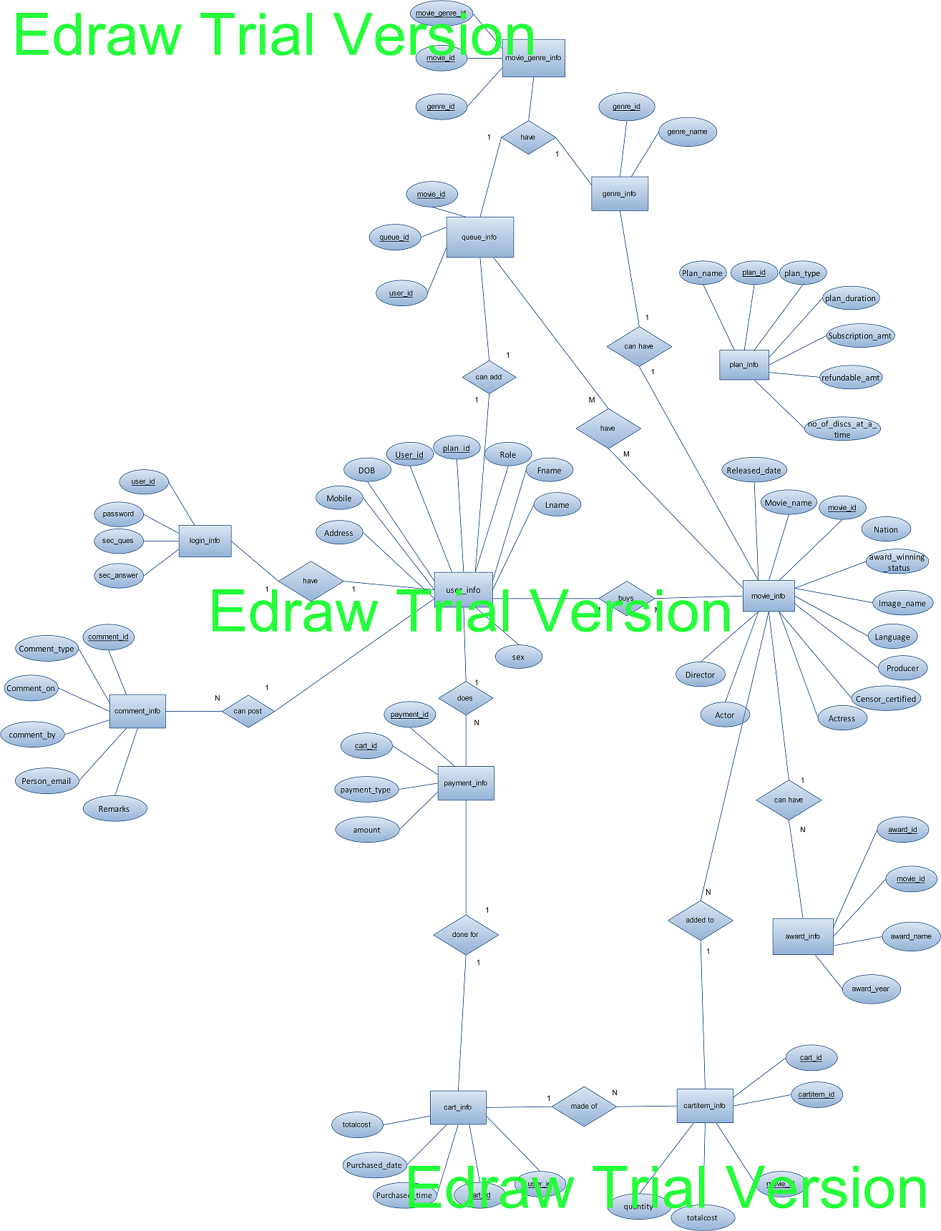
Data Structure

- Table: plan_info

To maintain the records of different plans

Column Name | Data Type | Size | Constraint | Description
plan_id | Number | 5 | Primary key | Plan id of the plan
Plan_name | Varchar2 | 30 | Not null | Name of the plan
plan_type | Varchar2 | 10 | Not null | Type of plan
plan_duration | Varchar2 | 12 |  | Duration of the plan
Subscription_amt | Number | 5 | Not null | Amount to subscribe the plan
refundable_amt | Number | 5 | Not null | Refundable amount
no_of_discs_at_a_time | Number | 10 | Not null | No of discs provided to the user

- Table: user_info

To maintain the records of different user either he/she is admin or user

Column Name | Data Type | Size | Constraint | Description
User_id | Varchar2 | 20 | Primary Key | User ID of user
plan_id | Number | 5 | Foreign key
Role | Varchar2 | 10 | Not null | Role of user
Fname | Varchar2 | 20 | Not null | First name of user
Lname | Varchar2 | 20 |  | Last name of user
Sex | Varchar2 | 6 | Male, Female | Gender of the user
Address | Varchar2 | 50 |  | Address of user
Mobile | Number | 10 | Not null | Mobile number of user
DOB | date |  | Not null | Date of birth of user

- Table: login_info

To maintain the username and the related password of different admin/user/staff

Column Name | Data Type | Size | Constraint | Description
User_id | Varchar2 | 20 | Foreign key | Valid email
Password | Varchar2 | 20 | Not null | Password of user for login
Sec_ques | Varchar2 | 20 | Not null | Security question of user for regaining the password details
Sec_answer | Varchar2 | 50 | Not null | Security answer of user for regaining the password details

- Table: movie_info

To maintain the username and the related password of different admin/user

Column Name | Data Type | Size | Constraint | Description
Movie_id | Number | 5 | Primary key | Movie id of the movie
Movie_name | Varchar2 | 20 | Not null | Name of the movie
Released_date | Date |  |  | Released date of the movie
Director | Varchar2 | 20 | Not null | Director of the movie
Actor | Varchar2 | 20 | Not null | Male Actor of the movie
Actress | Varchar2 | 20 | Not null | Female Actor of the movie
Producer | Varchar2 | 20 | Not null | Producer of the movie
Language | Varchar2 | 10 | Not null | Language of the movie
Censor_certified | Varchar2 | 5 | A, U/A, U | Censor certificate of the movie
Image_name | Varchar2 | 30 | Not null | Name of the image
award_winning_status | Number | 1 | 1 or 0 | This shows that movie is award winning or not. By default movie is not award winning
Nation | Varchar2 | 13 | Indian or International | Nationality of the movie
No_of_discs | Number | 5 | Not null | No of discs of a particular movie

- Table: genre_info

To maintain the records of different genre

Column Name | Data Type | Size | Constraint | Description
genre_id | Number | 5 | Primary Key | Genre ID
genre_name | Varchar2 | 15 | Action, Comedy, Drama, Horror, Family, Spiritual, Historical, Romance, etc | Name of the genre

- Table: movie_genre_info

To maintain the records of each movie with its genre

Column Name | Data Type | Size | Constraint | Description
movie_ genre _id | number | 5 | Primary key | Combine ID of both Movie ID & Genre ID
movie_id | Number | 5 | Foreign key | Movie ID
genre _id | Number | 5 | Foreign Key | Genre ID

- Table: award _info

To maintain the records of awards of each movie

Column Name | Data Type | Size | Constraint | Description
award_id | Number | 5 | Primary Key | Category ID
Movie_id | Number | 5 | Foreign key | Movie ID
award_name | Varchar2 | 30 |  | Name of the award
award_year | Date |  |  | On what date award is given to the movie
- Table: queue _info

To maintain the records of movies added by the user in queue

Column Name | Data Type | Size | Constraint | Description
queue_id | Number | 10 | Primary key | Queue ID
movie_id | Number | 10 | Foreign key | Movie ID
user_id | Varchar2 | 20 | Foreign key | User ID to whom movie is allotted
status | Varchar2 | 20 |  | Status of the movie that is either awaiting, delivered or reserve
Reserved_date | date |  | Not null | On what date movie is reserved by the user

- Table: delivery_history _info
To maintain the records of movies that was delivered to the user

Column_name | Data Type | Size | Constraint | Description
delivery_history _id | Number | 5 | Primary Key | Cart ID that we generate during the creation of the cart
Movie_id | Number | 5 | Foreign key | Movie ID of the movie_info table
User_id | Varchar2 | 20 | Foreign key | User ID of the user_info table
delivered_on | Date |  | Not null | Delivery date of the movie
Returned _on | Date |  | Not null | Returned date of the movie
Delivered_by | Varchar2 | 5 | Foreign key | User ID of a specific staff from the user_info table who delivered this movie to the user

- Table: request _info
To maintain the records of movies that are requested by the user from his/her queue

Column Name | Data Type | Size | Constraint | Description
request_id | Number | 5 | Primary Key | CartItem ID
Queue_id | Number | 5 | Foreign Key | Cart ID of the cart_info table
- Table: payment _info

To maintain the records of payment of each payment when user chooses his/her membership plan

Column Name | Data Type | Size | Constraint | Description
Payment_id | Number | 5 | Primary Key | Payment ID
User_id | Varchar2 | 20 | Foreign key | User ID of the user_info table to check who pay this payment to us
Payment_type | Varchar2 | 10 | Credit Card | Type of payment user want to pay
Amount | number | 5 | Not null | Amount of payment that was paid by user
Payment_date | Date | 7 | Not null | Payment date
Payment_time | Varchar2 | 5 | Not null | Payment time

- Table: payment _info

To maintain the records of comments posted by the user

Column Name | Data Type | Size | Constraint | Description
Comment_id | Number | 5 | Primary Key
Comment_type | Varchar2 | 10 | Suggestion, Complaint, Query | Types of comments the user can post
Comment_on | Varchar2 | 10 | Mall Services, Stores, Dining, Staff, Others | Thing on which user want to comment
comment_by | Varchar2 | 10 |  | Name of the person who post the comment
Person_email | Varchar2 | 30 | Not null | Email address of the person
Remarks | Varchar2 | 100 | Not null | The comment that he/she want to post

System Design

Data Flow Diagram

The Data flow Diagram shows the flow of data. It is generally made of symbols given below:

(1) A square shows the Entity:-

(2) A Circle shows the Process:-

(3) An open Ended Rectangle shows the data store:-

(4) An arrow shows the data flow:-

The DFD can be up to several levels. The 0 level DFD states the flow of data in the system as seen from the outward in each module.
The first level DFD show more detail, about the single process of the 0 level DFD
The second level DFD can show even more details and so on.

Context Level (0 Level) Diagram

Movie Rental
Customer
Admin
Database

1 Level DFD

payment details
Customer
Movie on Rental
Payment confirmation
Admin
Login
Register
Register
Login
Add Movie
Add Staff
Acknowledgment
Staff_ID
Movie_ID
Acknowledgment

1.1 Level
Add Movie To Queue
Customer
Selection of movie
Show Updated Movies
Queue Table

Fig. 1 Add Item to queue

1.2 level
Movie Table
movie_id
Add Movie
Admin
Add Movie

Fig 2 Add Movie

1.3 level

User & Login
Table
user_id
Details
Customer
Register

Fig. 3 Register

1.4 level

User & Login
Table
User ID & Password
Customer
Login
Admin
User ID & Password
Acknowledge
Acknowledge
User ID & Password
Role

Fig. 4 Login
1.5 level

User Table
Mode of payment &
Details
Customer
Payment
Payment
Confirmation
Payment Table

Fig. 5 Payment Details

System Design

UML Diagram

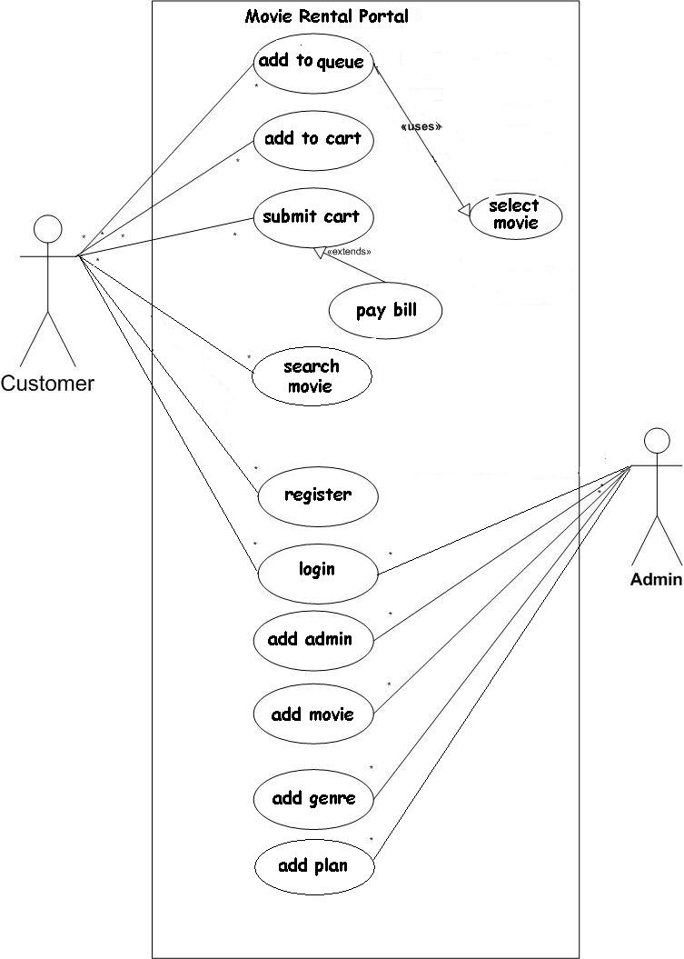
Bibliography

Bibliography

Web Resources

- www.java.sun.com
Official Java Website
- www.java.sun.com/developer/onlineTraining/J2EE/Intro2/j2ee.html
Training for J2EE
- www.java.sun.com/j2se/1.4.2/docs/api/index.html
J2SE Online Documentation from Sun
    - www.w3schools.com
JavaScript Tutorials

BOOKS

- API DOCS –JAVA, J2EE, Java Mail, Java Servlets, JSPs
By: Sun Microsystems

- Java2 - The Complete Reference(7TH Edition)
By: Herbert Schildt

- JSP - The Complete Reference
By: Philhanna

- Oracle 10g
By: Ivan Baross

- Software Engineering
By: Roger Pressman

- Head First Servlets & JSP
By: Bryan Bashan, Kathy Sierra & Bert Bates

